Appendix J

Web Database Development with ColdFusion

Discussion Focus

Here is a good opportunity to take a look at the “big picture” of Internet database development. Review the main points in Chapter 14, “Database Connectivity and Web Development” and Appendix J, “Web Database Development with ColdFusion.” Specifically, focus on:
- Different database connectivity technologies.
- Multi-tier architecture for database development.
- How Web-to-database middleware is used to integrate databases with the Internet.

Rather than showing you long code listings in this manual, we guide you through the solution steps as they are found in the script files located on the Instructor’s CD. Using this technique, the student can step through the solutions and see the code at the same time.

Figure J.1 shows the RobCor ColdFusion application’s main menu.

Figure J.1 RobCor Teacher Menu
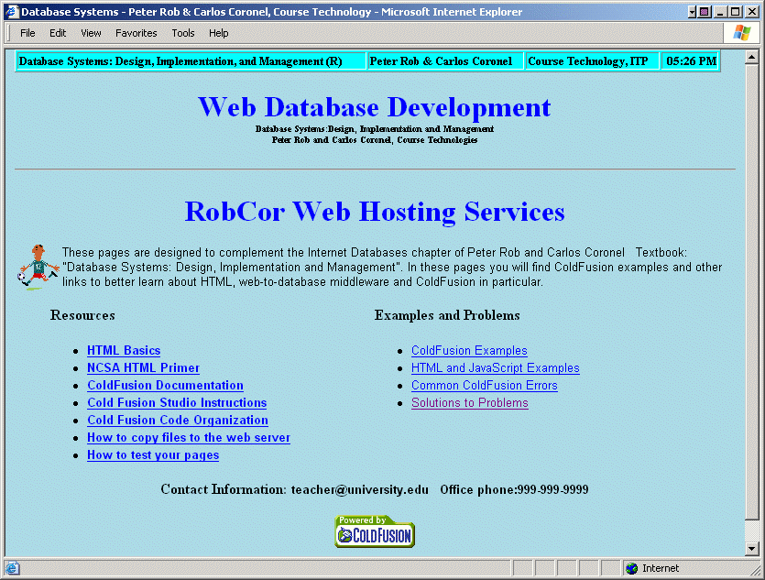

The ColdFusion Problem Solutions section is a menu driven system that guides you through all of the solutions for this appendix. For example, if you click on the Solutions to Problems link (See Figure J.1) you will open the page shown in Figure J.2.

Figure J.2 RobCor Problem Solutions Menu
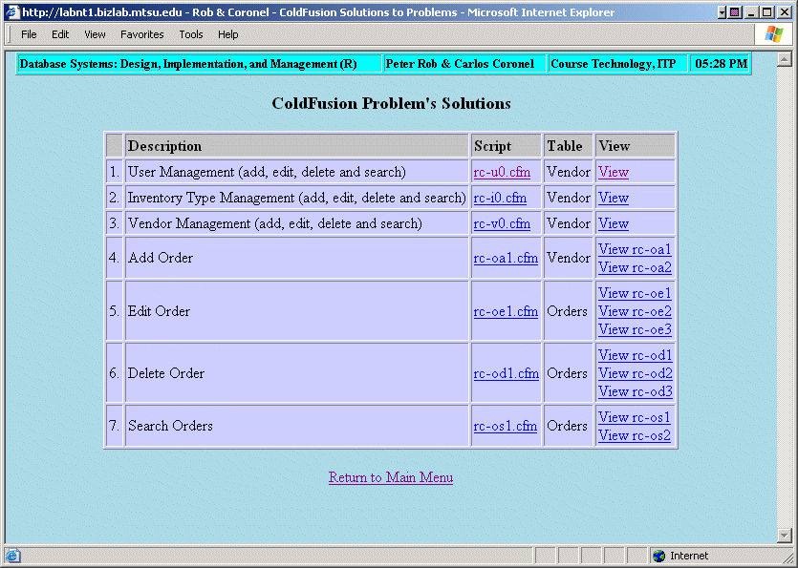

If you click on the View link for the first row shown in Figure J.2, you will see the code for the rc_u0.cfm script in Figure J.3.

Figure J.3 RobCor View Code Sample
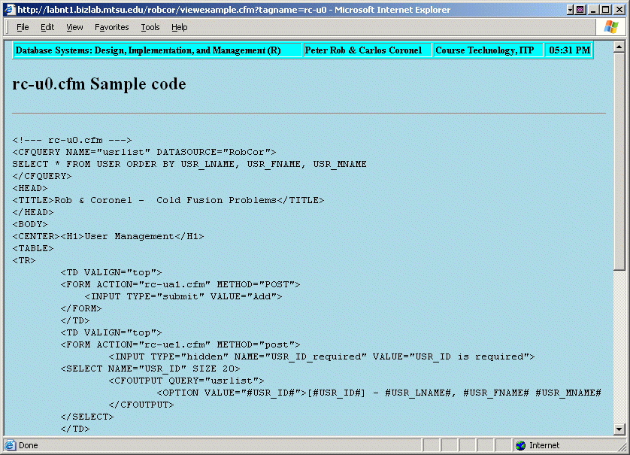

Answers to Review Questions

- What are scripts, and how are they created in ColdFusion?

Scripts are a series of instructions interpreted and executed at run time. Scripts are used in web-database application development to instruct the application server components what actions to do, such as connect, query, and update a database from a web front-end. Scripts are, for the most part, transparent to the clients. The application developer must create scripts to access the database and to create the web pages dynamically. The application server executes the scripts and passes the results (output) to the web server in HTML format.

- Describe the basic services provided by the ColdFusion Web application server.

The ColdFusion Web Application Server provides the following services (among others):
- Integrated Development Environment.
- Session management with support for persistent application variables.
- Security and authentication.
- A computationally complete programming language (commands and functions) to represent and store business logic.
- Access to other services: FTP, SMTP, IMAP, POP, etc.

- Discuss the following assertion: The web is not capable of performing transaction management.

Note the discussion in Section J.2.3, Transaction Management.

The concept of database transactions is foreign to the Web. Remember that the Web’s request-reply model means that the Web client and the Web server interact by using very short messages. Those messages are limited to the request for and delivery of pages and their components. (Page components may include pictures, multimedia files, and so on.) The dilemma created by the Web’s request-reply model is that:
- The Web cannot maintain an open line between the client and the database server.
- The mechanics of a recovery from incomplete or corrupted database transactions require that the client must maintain an open communications line with the database server.

- Transaction management is critical to the e-commerce environment. Given the assertion made in Item 3, how is transaction management supported?

Clearly, the creation of mission-critical Web applications mandates support for database transaction management capabilities. Given the just-described dilemma, designers must ensure proper transaction management support at the database server level.

Many Web-to-middleware products provide transaction management support. For example, ColdFusion provides this support through the use of its CFTRANSACTION tag. If the transaction load is very high, this function can be assigned to an independent computer. By using that approach, the Web application and database servers are free to perform other tasks and the overall transaction load is distributed among multiple processors.

- Describe the Web page development problems related to database parent/child relationships.

This condition is addressed in detail in Section J.2.4, Denormalization of Database Tables. Specifically, note the following:

When the Web is used to interact with databases, the application design must take into account the fact that the Web forms cannot use the multiple data entry lines that are typical of parent-child (1:M) relationships. Yet those 1:M relationships are crucial in e-commerce. For example, think of order and order line, or invoice and invoice line. Most end users are familiar with the conventional GUI entry forms that support multi-table (parent-child) data entry through a multiple-component structure composed of a main form and a subform. Using such main-form/subform forms, the end user can enter multiple purchases associated with a single invoice. All data entry is done on a single screen.

Unfortunately, the Web environment does not support this very common type of data entry screen. As illustrated in the ColdFusion script examples, the Web can easily handle single-table data entry. However, when multi-table data entries or updates are needed—such as order with order lines, invoice with invoice lines, and reservation with reservation lines—the Web falls short. Although implementing the parent/child data entry is not impossible in a Web environment, its final outcome is less than optimum, usually counterintuitive, less user-friendly, and prone to errors.

To see how the Web developer might deal with the parent/child data entry, let’s briefly examine how you might deal with the ORDER and ORDER_LINE relationship used to store customer orders. Using an applications middleware server such as ColdFusion to create a Web front end to update orders, one or more of the following techniques might be used:
- Design HTML frames to separate the screen into order header and detail lines. An additional frame would be used to provide status information or menu navigation.
- Use recursive calls to pages to refresh and display the latest items added to an order.
- Create temporary tables or server-side arrays to hold the child table data while in the data entry mode. This technique is usually based on the bottom-up approach in which the end user first selects the products to order. When the ordering sequence is completed, the order-specific data, such as customer ID, shipping information, and credit card details, are entered. Using this technique, the order detail data are stored in the temporary tables or arrays.
- Use stored procedures or triggers to move the data from the temporary table or array to the master tables.

Although the Web itself does not support the parent/child data entry directly, it is possible to resort to Web programming languages such as Java, JavaScript, or VBScript to create the required Web interfaces. The price of that approach is a steeper application development learning curve and a need to hone programming skills. And while that augmentation works, it also means that complete programs are stored outside the HTML code that is used in a Web site.

Problem Solutions

In the following exercises, you are required to create ColdFusion scripts. When you create these scripts, include one main script to show the records and the main options, for a total of five scripts for each table (show, search, add, edit, and delete). Consider and document foreign key and business rules when creating your scripts.

- Create ColdFusion scripts to search, add, edit, and delete records for the USER table in the RobCor database.

This problem’s solution is contained in the system summary below problem 5.

- Create ColdFusion scripts to search, add, edit, and delete records for the INVTYPE table in the RobCor database.

This problem’s solution is contained in the system summary below problem 5.

- Create ColdFusion scripts to search, add, edit, and delete records for the VENDOR table in the RobCor database.

This problem’s solution is contained in the system summary below problem 5.

- Modify the insert scripts (rc-5a.cfm and rc-5b.cfm) for the DEPARTMENT table so the users who can be manager of a department are only those who belong to that department.

This problem’s solution is contained in the system summary below problem 5.

- Create an Order data-entry screen, using the ORDERS and ORDER_LINE tables in the RobCor database. To do this, you can use frames and other advanced ColdFusion tags. Consult the online manual and review the demo applications.

NOTE
The following pages show sample ColdFusion scripts that are required by the problem set. To avoid repetition and to save space, we have illustrated only one example of each script type (select, insert, update, and delete). Use the Instructor’s CD to access the complete list of ColdFusion scripts. To install ColdFusion and the scripts follow the instructions in the ColdFusion_Setup.doc

This series of exercises requires the student to create the data manipulation scripts for the USER, INVTYPE and VENDOR tables. The logic used in these scripts is the same as the one shown in Appendix J “Web Database Development with ColdFusion”.

To produce a user-friendly environment, we have created a menu to access all USER table database operations. The menu lets the user add, edit, delete, and search records in the USER table. Please refer to the solution scripts found on the Instructor’s CD.

The menu script, named rc-u0.cfm produces the output shown in Figure PJ.1.

Figure PJ.1 The User Management Menu
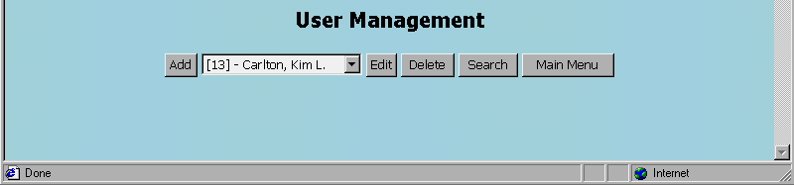

The following pages list scripts that are required to add, edit, delete and search records. For a complete listing please refer to the Instructor’s CD.

Inserting Records in the USER Table

The rc-ua1.cfm script produces the data entry screen shown in Figure PJ.2. This data entry screen consists of an HTML form that contains several input boxes to enter the data.

Figure PJ.2 The Add User Web Form
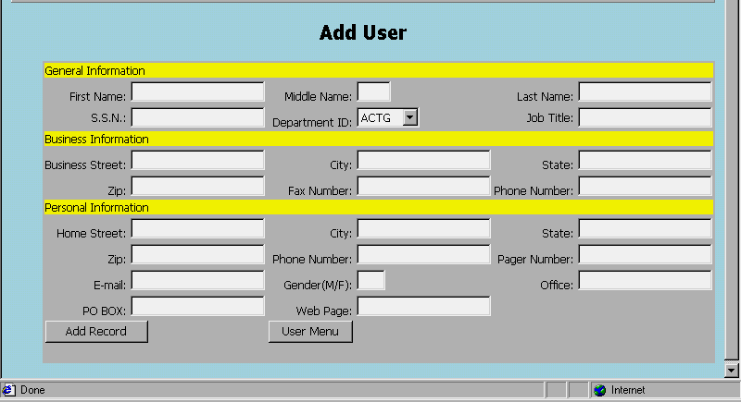

When the user clicks the Add button, script rc-ua2.cfm is invoked. The cc-ua2.cfm script uses the CFINSERT tag to add a row to the database. (Check Figure PJ.3 to see the script’s effect.)

Figure PJ.3 The Add User Results
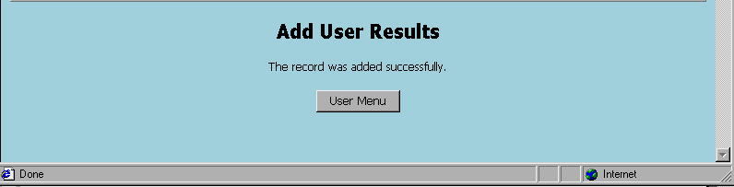

Updating Records in the USER Table

The rc-ue1.cfm script will show all the data that match the USER_ID selected by the user. In addition, the script lets the end user modify the selected data. Figure PJ.4 shows the script’s output.

Figure PJ.4 The Edit User Form
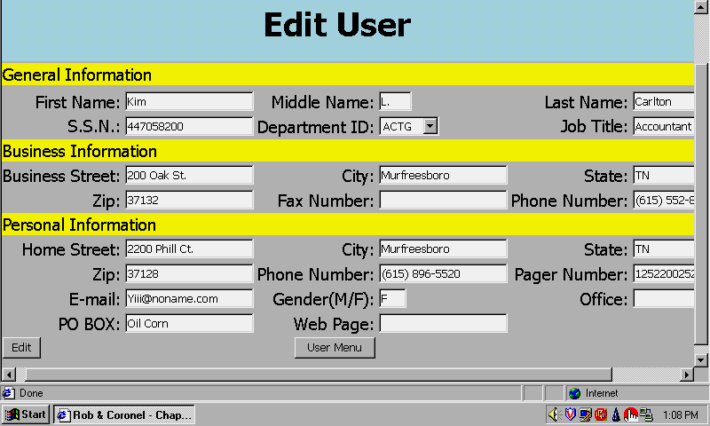

Clicking on the Add button will trigger the rc-ue2.cfm script, which runs the CFUPDATE tag to update the database. The rc-ue2.cfm script produces the output shown in Figure PJ.5.

Figure PJ.5 The Edit User Results Screen
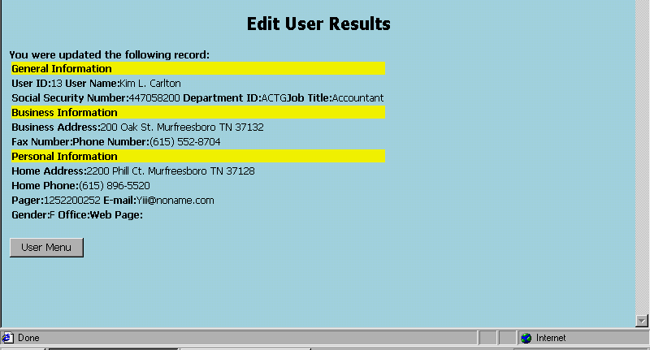

Deleting Records from the USER Table

The rc-ud1.cfm script produces the results shown in Figure PJ.6.

Figure PJ.6 The Delete User Form
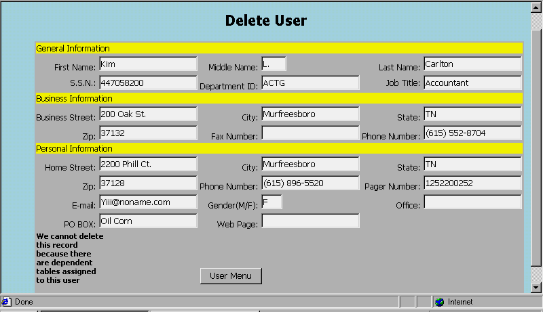

In this rc-ud1.cfm script, the Delete button is shown only if this user is not a manager of a department and does not have any orders in the ORDERS table. Otherwise, the script will not allow you to delete the USER record. After clicking on the Delete button, the rc-ud2.cfm script is invoked. The rc-ud2.cfm script produces the output shown in Figure PJ.7.

Figure PJ.7 The Delete User Results Screen
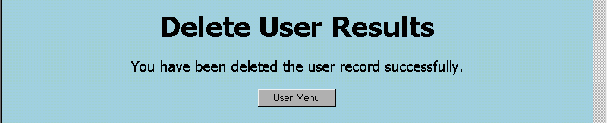
You have deleted the user record successfully

Searching for Records in the USER Table

The rc-s1.cfm script produces the output shown in Figure PJ.8.

Figure PJ.8 The Search User Form
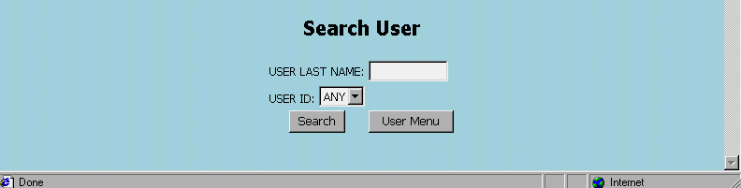

Figure PJ.8's very simple screen lets the end user enter a last name to conduct a search in the USER table -- or the end user may select a user id as the search key. Clicking on the Search button invokes the rc-us2.cfm script. The rc-us2.cfm script produces the output shown in Figure PJ.9.

Figure PJ.9 The Search User Results Screen
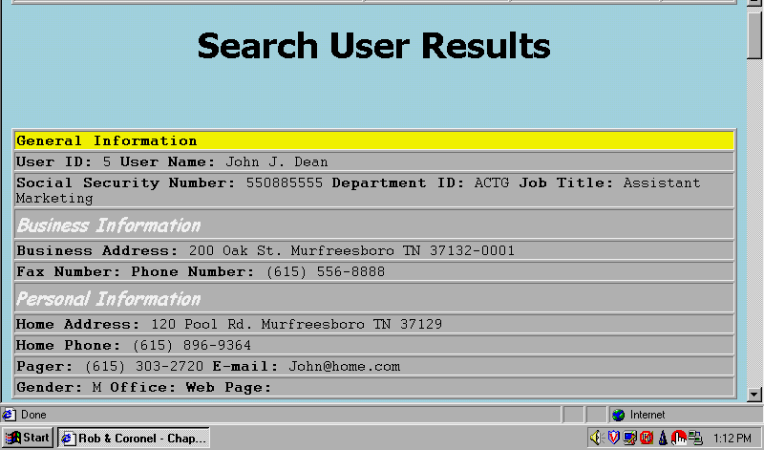

Note that the insert script (rc-5a.cfm and rc-5b.cfm) for the Department table only lists the users that can be manager of a department. The key to this script is in the SELECT SQL statement. (Note the condition used in the WHERE clause. This condition lists only those users who are not already managers of a department.)

<CFQUERY NAME="USRLIST" DATASOURCE="RobCor">
SELECT USR_ID, USR_LNAME, USR_FNAME, USR_MNAME

FROM USER

WHERE USR_ID NOT IN (SELECT USR_ID FROM DEPARTMENT WHERE USR_ID > 0)

ORDER BY USR_LNAME, USR_FNAME, USR_MNAME
</CFQUERY>

The rc-5a.cfm script produces the output shown in Figure PJ.10.

Figure PJ.10 The Department Data Entry Screen
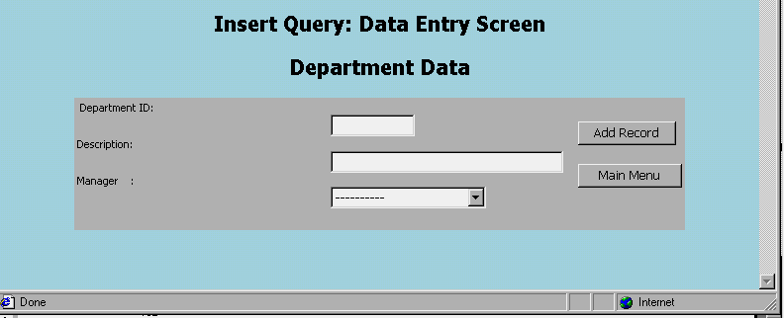

Script rc-5b.cfm script uses a CFINSERT tag to add the data to the database. The script rc-5b.cfm output is shown in Figure PJ.11.

Figure PJ.11 The Department Insert Query
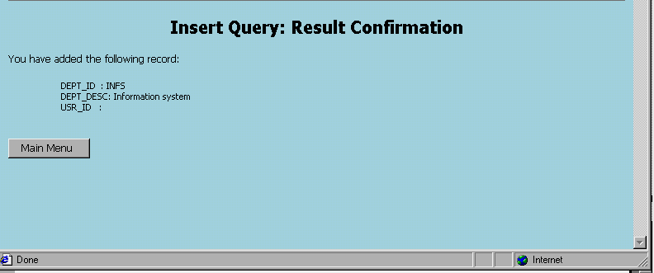

Challenge Project

Create an Order data entry screen, using the ORDERS and ORDER_LINE tables in the RobCor database. (To complete this problem successfully, you should know how to use frames and ColdFusion tags. Please consult the online ColdFusion manual and study the demo applications to learn how such components can be developed.)

This challenge project requires the student to know HTML coding and the use of frames. In addition, some type of CGI programming or Java/JavaScript programming is recommended. Although our chapter 14 provides the basis for your students to develop Web to database interfaces, it does not cover all the components required to complete this problem. Therefore, you might pitch this problem at students who have some prior Web development experience. (Or perhaps you used supplemental material to examine our database design and implementation material from an applications development point of view!)

Even if your students do not (yet) have the appropriate Web application development skills, they will find the following discussion interesting and useful for several reasons. First, they will have a chance to revisit some important database design and implementation issues in a Web environment. Second, they will be exposed to some of the details of Web database applications development. Finally, they may even store this problem into their minds, to be dusted off when they take Web-based classes!

From a design standpoint, the developer can approach this problem from several different angles:
- Create a multiple frame page that will have one frame for the ORDER header information and another for the ORDER_LINE data entry. In this case, the ORDER data will have to be entered, validated and saved first, before the ORDER_LINE frame is shown or accessed. Once the main ORDER data are saved, the second frame can be used to enter the ORDER_LINE rows. Both frames use buttons that will enable the system to accept data entry and to perform validation checks. This solution is not particularly well suited to a commercial e-commerce environment for two good reasons:
- The end-user navigation among frames is awkward and is likely to be rejected by end users.
- Keeping both frames synchronized is difficult and, unless the coding is particularly robust, is prone to failure.
  - A second way to tackle this problem is to borrow the typical “shopping cart” style used by most on-line stores. Students can go to Amazon, Sears, or to any other on-line store to step through the process of purchasing a product online. This process usually starts with the selection of all of the desired items and then progresses to the payment component. In other words, the process first collects the order line data and then, at its conclusion, collects the (invoice) payment data. Given this scenario, the browser must use temporary tables to store the data for the orders in progress. Later, such data are used to update the production database. In between, business logic is used to validate the data and to save such data in the proper format. The business logic is implemented through the use of cgi programs such as PERL, Java, etc. In addition, the business logic component usually employs stored procedures in the database environment. This solution generally preferred by on-line stores, because it is based on well-established and proven technology. (In fact, you can even buy applications that provide the entire shopping cart feature straight out of the box!)
  - Using Java programming code or some plug-in application like Power-Builder may also solve the problem. This approach requires that the complete application be downloaded to the client computer, to be run locally. Given this scenario, the end user develops an interface that can handle the one-to-many simultaneous data entry format. The entire application logic is then sent to and executed by the client side. The client application is connected to the back-end database through the Web. This solution is similar to those offered by high-end web-to-database middleware products such as NetObjects, IBM’s WebSphere or Oracle 9i Web database. In most cases, the application will be in the form of a Java applet that works in tandem with a server applet.

